Trash Trader: Characters / Refs

# Main Characters:

Jonah Foxe (M) – MC – Raider of bins and seller of trash

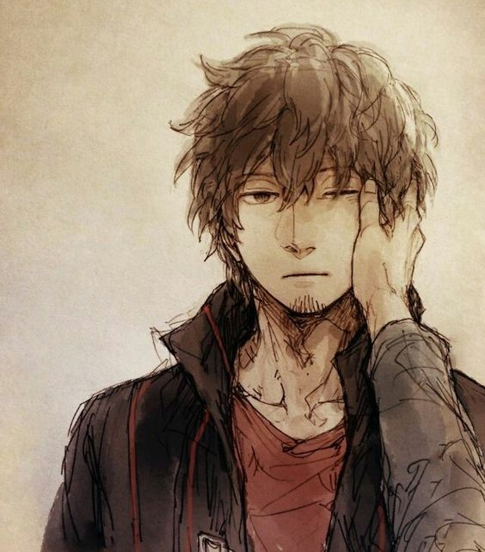

Mallory Wescotte (F) – Ojou – Collecter of curios (and debts) - unlucky

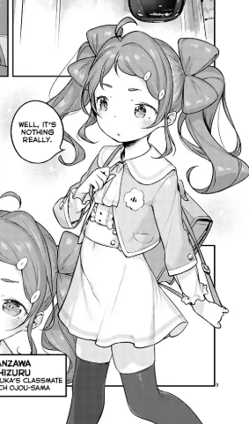

# Peasants Quarter:

Greysen Howlande (M)

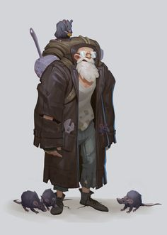 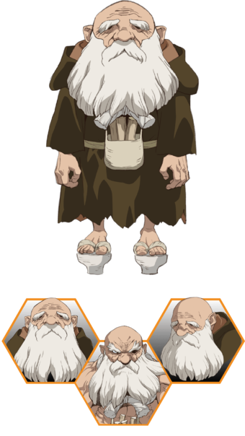

# Nobility Quarter:

Louella Arkwrighte (F) – Mallorys Bodyguard

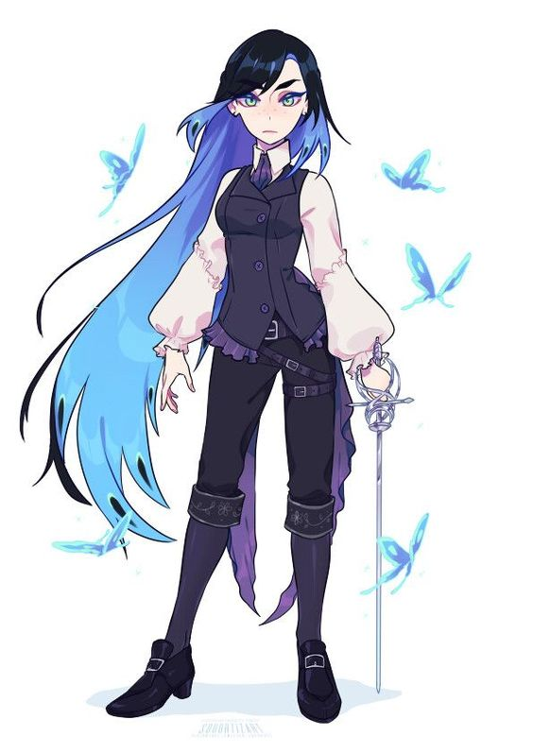

# Mine:

Edison Reede (M)

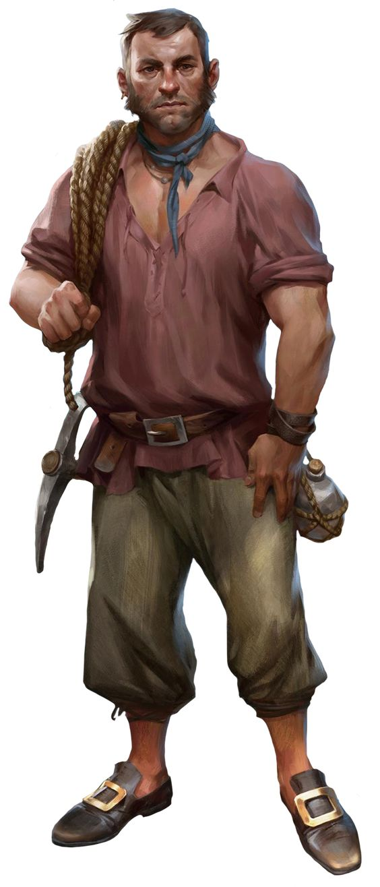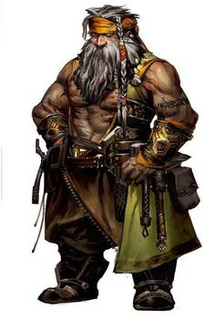

# Marketplace:

Bliss Clintone (F)

 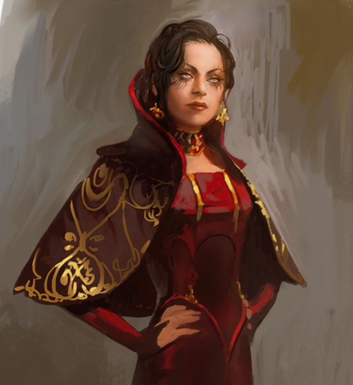 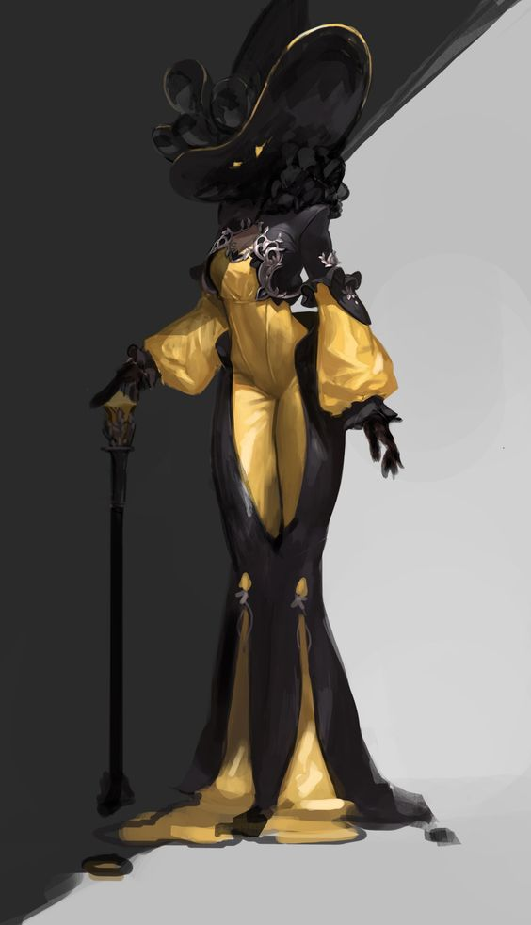 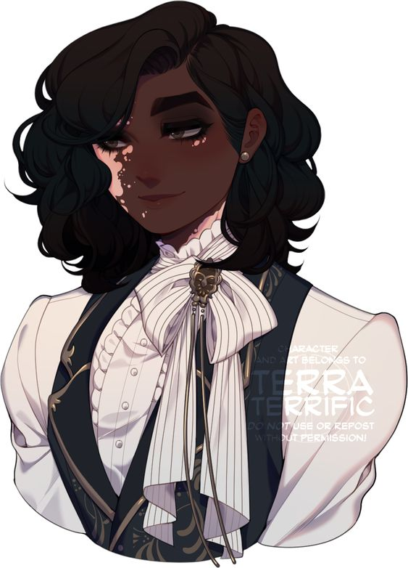

# Mages Guild:

Brinley Ecclestone (M)

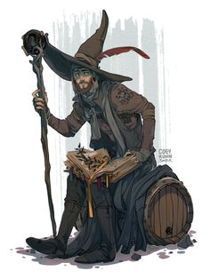

Cornelius Ecclestone (M) - Brinleys grandfather/cat



# Inn:

Ashley Gladwine (F)

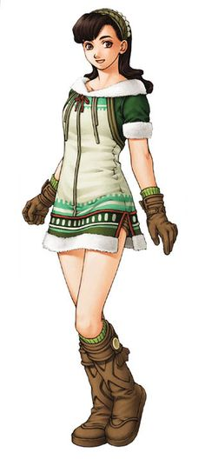  

# Hunting Guild:

Hildred Woodse (F)

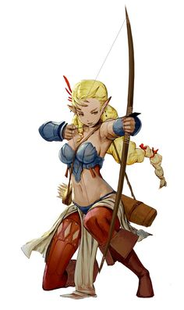 

# Forest:

Brandyn Alvine (M)

 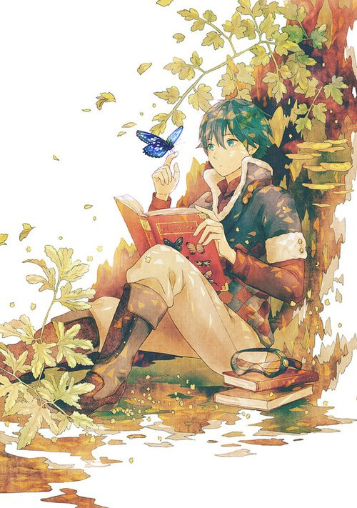

# Farm:

Clifford Aldene (M)

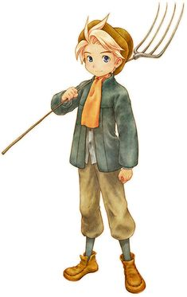

# Docks:

Lynn Froste (F)

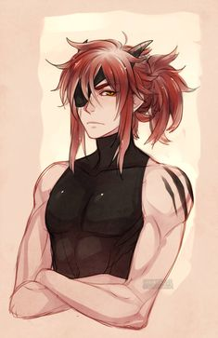

like this but a girl

# Church:

Marjorie Hathawaye (F)



# Castle:

Prince Edwin Hardwicke (M)

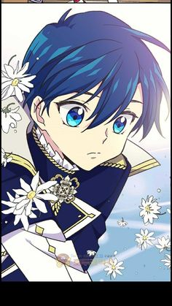

# Blacksmith:

Cordell Goode (F)

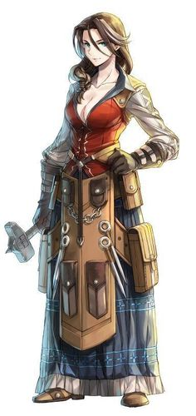

# Warehouse:

Crawford Froste (M)



# Barracks:

Slade Greye (M)

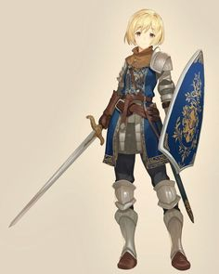

# Adventure Guild:

Linton Thorleye (M)

